Ecology Test 2015

- As a population grows, factors that slow or limit the growth of the population include all except:
- Disease and parasitism
- Immigration
- Predation
- Competition for resources

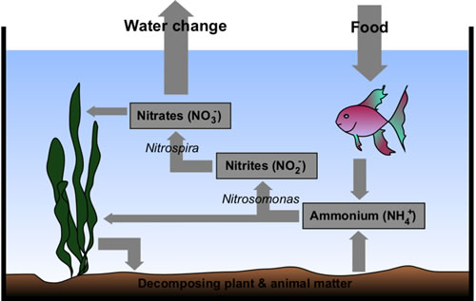
When the fish is provided with so much food that it cannot eat all of it, the excess food
- helps to remove nitrogenous wastes from the aquarium
- kills bacteria
- can be absorbed by the plant for photosynthesis
- adds to the nitrogenous wastes in the aquarium
3.
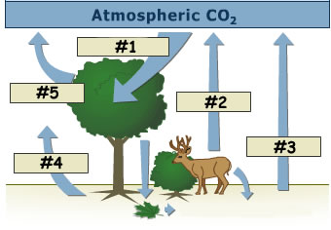
Process #2 adds carbon dioxide to the atmosphere by means of
- decomposition
- evapotranspiration
- respiration
- photosynthesis
- deamination

