Let’s SYNTHESIZE Science
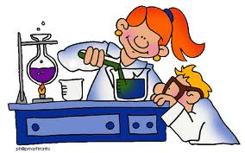

Topic:__________________

- What do you predict we will learn next? Explain. ____________________________________________________________________________________________________________________________________________________________________________________________________________________________________________________

- How would you create/design an activity to help you understand today’s objective?
____________________________________________________________________________________________________________________________________________________________________________________________________________________________________________________

- REVISE the most confusing section of your notes or thoughts from today.
____________________________________________________________________________________________________________________________________________________________________________________________________________________________________________________

- FORMULATE a plan or find an unusual way to study/remember today’s lesson.
____________________________________________________________________________________________________________________________________________________________________________________________________________________________________________________

