Biology Quick Concept Review
Ecology
- Levels of organization- (from smallest to largest)
- cells-> tissues-> organs-> organism-> population-> communities-> ecosystems-> biomes-> biosphere
- species- a group of organisms that interbreed and produce fertile offspring
- Population- one species
- Community- population + population+ population
- Ecosystem- biotic+ abiotic
- Identify impact on a food web in an ecosystem based on the introduction or extinction of an organism. Refer to the diagram below;
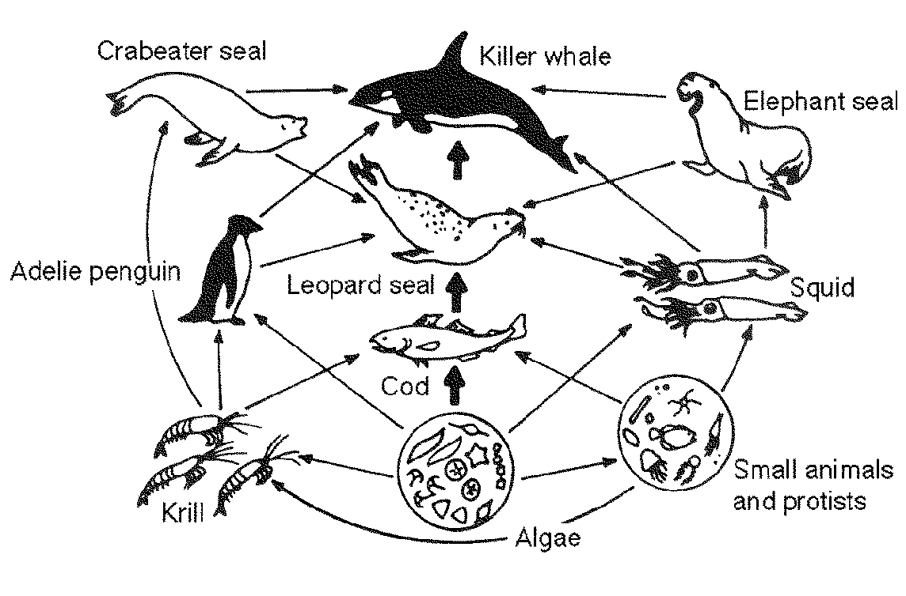
- Ten percent Law- Only ten percent of the energy is passed from one trophic level to the next. At each level, 90 percent of the energy is lost due to life processes, metabolism, and death before consumption (heat). Refer to the picture below;

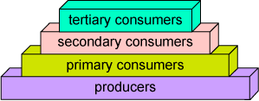
- Evaporation- sun driven process of water cycle that requires the most energy
- Condensation (The formation of clouds) releases heat in the atmosphere
- Nitrogen Cycle- Largest reserve of Nitrogen is in the atmosphere. It is unusable to living organism. Bacteria “FIX” the nitrogen to make it useable to others in a process known as nitrogen fixation.
Bacteria->plants->animals-> decomposers
- Carbon cycle: burning of fossil fuels=greenhouse effect and acid rain

Cells
- Prokaryotes-(Pro- without or lacking) lack nucleus and membrane bound organelles
- Passive Transport- lack energy
- Active Transport- Need energy (ATP)
- Hypertonic environment- Water moves out; Cell Shrinks/shrivels; more sugar/salt (solute) *sugar makes you HYPER
- Hypotonic environment- Water moves in; Cell Swells
- Enzyme- ase ending EX: polymerase. Speeds up a reaction; increases reaction rate; lowers activation energy.( Enzyme will get you there in time)

Cellular Metabolism
- Photosynthesis- occur in the chloroplast of autotrophs/producers (The opposite equation of cellular respiration)
- Cellular Respiration- occur in the mitochondria of eukaryotic cells (The opposite equation of photosynthesis)

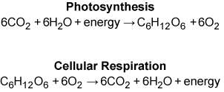

- Both Photosynthesis and Cellular Respiration are major processes that take in and release carbon into the atmosphere.
- ATP is a storage molecule of energy. ATP looses a phosphate and turns to ADP and lots of energy is released
- Aerobic=36 ATP; anaerobic=lactic acid or ethanol (ethyl alcohol) or other alcohol

Cellular Reproduction
- Mitosis Meiosis
Body cells sex cells or gametes
Ends with two cells (diploid) Ends with four cells that are half # of the parent (haploid)
Identical copies of parent genetically diverse (crossing over; law of independent assortment)

Cell Differentiation
- Cell Differentiation occurs when cells begin becoming specialized. This occurs in the Gastrula stage. Refer to diagram below.
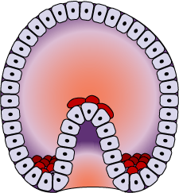
Nucleic Acids and Protein Synthesis
- DNA RNA
Made of nucleotides Made of nucleotides
Double helix single strand
Contains information to code for proteins made by DNA to make proteins (transcription)
Too large to leave the nucleus and make proteins
Nitrogen Bases include; A,T,G,C Nitrogen Bases include; A, U, G, C
Blueprint of life

- Replication- DNA making DNA
- Transcription- DNA to RNA
- Translation- RNA to Proteins

DNA--------------------------RNA---------------------Proteins
(Nucleus) (Ribosome)
Transcription Translation

- Amino Acids- Building blocks of proteins
- mRNA- messenger (nucleus to ribosome; codons); tRNA transfer (ribosome; anticodons amino acids); rRNA ribosomal

Genetics

- Homozygous- alleles the same
- Heterozygous- different alleles
- Genotype- genes (two letters) EX: TT, Tt, tt
- Phenotype- physical ( how it appears) EX: Tall or short
- Monohybrid cross- a cross between one pair of contrasting traits EX: Plant height
- Dihybrid cross- a cross between two pairs of contrasting traits EX: Plant height and flower color
- Pedigree chart- useful when determining occurrences and probability of genetic disorder. Show family genetic history
Autosomal- occurs in both male and females
X-linked (sex linked)- mostly males
Dominant- occurs in every generation
Recessive- skips a generation

Classification
- A dichotomous key is used when identifying unknown organisms
- **Be able to use a dichotomous key for identification of organisms
- **Review major characteristics of the domains and kingdoms
- Scientific name= Genus species
Evolution
- Mutation- a random change in the DNA sequence that results in genetic variation of the species
- Evolution- change over a period of time; change over generations
- Natural Selection- the process (HOW) by which evolution occurs. It states that there is variation among a group of organisms and some organisms are more “FIT” for their environment. Due to lack of resources, mates etc., competition results. The organisms that are most “fit” for their environment will be the ones that reproduce and pass their genes onto the next generation, therefore, being “selected for by their environment.” NONRANDOM
- Gene Flow- the physical movement of alleles from one population to another. Can increase variation with in a population
- Genetic Drift- the change in the frequency of alleles due to disease, starvation, change in the environment, or natural disaster
- Bottlenecking- genetic drift (gene loss) that drastically reduces the size of a population. Refer to diagram below;
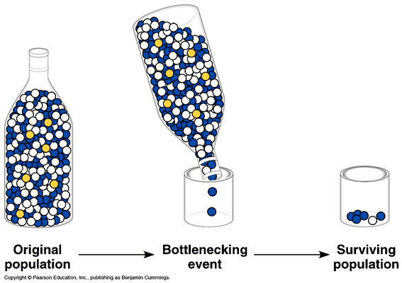
- Cladogram/Phylogenic Tree- a diagram that shows organisms classified based on evolutionary history. Refer to diagram.
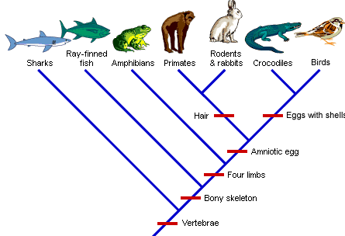
- Homologous structure- same ancestor, same structure, different function
- Analogous structure-different ancestor, different structure, same function
- Convergent-two species share a common trait that serves the SAME FUNCTION: dolphin and shark tail
- Divergent- one species changes into two species over a period of time: bird buzzard and penguin
- Coevolution- species evolve in response to one another. EX: hummingbird and fuchsia flower
- Microevolution-little variation in ONE species-ex: dogs
- Macroevolution-a lot of variation; results in two or more species

Health and Disease
- Bacteria- living, prokaryotes, DNA present, treated with antibiotics
- Viruses- nonliving, contain DNA or RNA, reproduce in host, no cure only treatment with antiviral drugs, some are prevented with vaccinations
- Major transmission of pathogen is through bodily fluids
- Immune systems- fights of pathogens
- 1st line of defense- skin and mucous membranes
- 2nd line of defense- inflammation, fever, and leukocytes (WBC)
Macrophage- eats pathogen (Pac man)
B- cell- destroys pathogen in body before it enters cell
T-cell- destroys body cells that have been infected with pathogen
- 3rd line of defense
a. pathogen enters
b. Histamine released: inflammation and swelling occurs rushing in WBC
c. pathogen is recognized by its antigen (flag for antibody)
d. Body makes antibody to recognize antigen—killer cells recognize antibody
e. body makes more antibodies
f. immunity
- Type of Immunity
Passive- short term EX: mother passing immunity to baby through breast milk
Active- long term EX: vaccination
- Reproduction structures and functions
- Trimesters of pregnancy

Macromolecules
 | Carbohydrates | Proteins | Lipids | Nucleic acids
Monomer | saccharide | Amino acid | Fatty acid | nuclnucleotide
 | 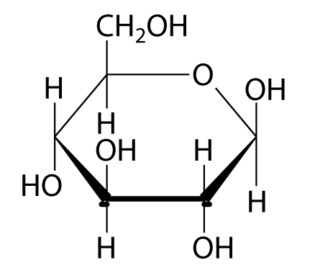 | 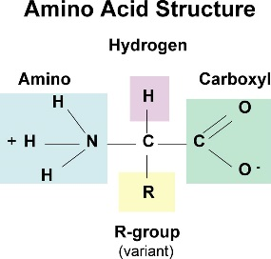 | 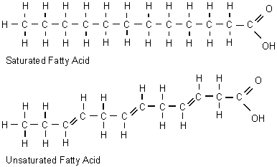 | 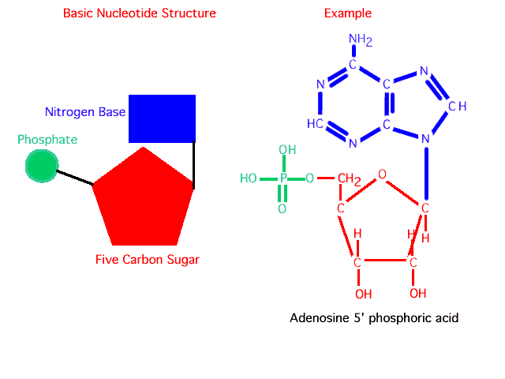
 | CHO  Twice as many H  6O  C ring | Look for NH₂ | Chain of C with COOH | Sugar, phosphate, base
Function | Energy | structure | Phospholipid bilayer  protection | heredity

