The Origin of Life on Earth
Directions: read the article and IYB answer all of the bold, numbered prompts.
Chemical Evolution
The appearance of the first cells marked the origin of life on earth. However, before cells could form, the organic molecules must have united with one another to form more complex molecules called polymers. Examples of polymers are polysaccharides and proteins.
Did you know it was once believed that non-living things (like grain) could produce living things (like mice)? This idea was widely held until the mid-1890s! Louie Pasteur finally disproved this theory called Spontaneous Generation. Pasteur showed that the growth of bacteria in nutrient broths is not due to spontaneous generation, but rather to biogenesis (literally life from life). He further showed that fermentation is caused by the growth of micro-organisms. Finally, he showed that pasteurization (heating of liquids) sterilizes liquids and allows for long-term storage. The process was actually called 'pasteurization' as a way to honor Pasteur. You might be asking where this first life came from that all other life arose. Many other scientists are trying to answer that same question today.
In the 1950s, Sidney Fox placed amino acids in primitive earth conditions and showed that amino acids would unite to form polymers called proteinoids. The proteinoids were apparently able to act as enzymes and catalyze organic reactions.
- Throwback: analyze the production of a protein in the cell.
More recent evidence indicates that RNA molecules have the ability to direct the synthesis of new RNA molecules as well as DNA molecules. Because DNA provides the genetic code for protein synthesis, it is conceivable that DNA may have formed in the primitive earth environment as a consequence of RNA activity. Then DNA activity could have led to protein synthesis.
For a cell to come into being, some sort of enclosing membrane is required to hold together the organic materials of the cytoplasm. A generation ago, scientists believed that membranous droplets formed spontaneously. These membranous droplets called protocells were presumed to be the first cell. Modem scientists believe, however, that protocells do not carry any genetic information and lack the internal organization of cells. Thus the protocell theory is not widely accepted. Several groups of scientists are currently investigating the synthesis of polypeptides and short nucleic acids on the surface of clay. The first cells remain a mystery.

Ancient Life on Earth
Earth came into existence about 4.6 billion years ago, and about 3.8 billion years ago, the evolution of chemicals began. Scientists estimate that at about 3.5 billion years ago, the first cells were in existence.
Scientists believe that the first cells lived within the organic environment of the earth and used organic foods for their energy. The type of chemistry in those first cells was somewhat similar to fermentation, which uses organic molecules, such as glucose. The energy yield, although minimal, is enough to sustain living things. However, organic material would soon have been used up if this were the sole source of nutrition, so a new process had to develop.
The evolution of a pigment system that could capture energy from sunlight and store it in chemical bonds was an essential breakthrough in the evolution of living things. The organisms that possess these pigments are commonly referred to as cyanobacteria (at one time, they were called blue‐green algae). These single‐celled organisms produce carbohydrates by the process of photosynthesis. In doing so, they produce oxygen as a waste product. For a period of about 1 billion years, photosynthesis provided oxygen to the atmosphere, which gradually changed until it became oxygen rich, as it is today.
Another group of organisms that was present at the same time as the cyanobacteria was a group of bacteria called archaebacteria. Archaebacteria differ from “modern” bacteria (known as eubacteria) in that archaebacteria have a different ribosomal structure, different cell membrane composition, and different cell wall composition. The archaebacteria have been traced to a period of about 3 billion years ago. They are able to multiply at the very high temperatures that were present on the earth then, and their nutritional requirements reflect the composition of the primitive earth.
First Eurkaryotic Cells
The cyanobacteria and archaebacteria of the primitive earth are now referred to as prokaryotes (together with the modern bacteria). Approximately 1.5 billion years ago, in an oxygen‐containing atmosphere, the first eukaryotes came into being. Eukaryotes have a nucleus, a nuclear membrane, a number of organelles, a ribosomal structure different from that of prokaryotes, reproduction by mitosis, and other features that distinguish them from prokaryotes.
- Compare and Contrast prokaryotic and eukaryotic cells.
No one is certain how eukaryotes came into being. In the late 1960s Margulis studied the structure of cells and came up with the endosymbiotic theory which suggests that bacteria were engulfed by larger cells. The bacterial cells remained in the cell, assumed some of the chemical reactions for these cells, and became the mitochondria of these cells. The cells then reproduced and flourished. These cells became animal cells.
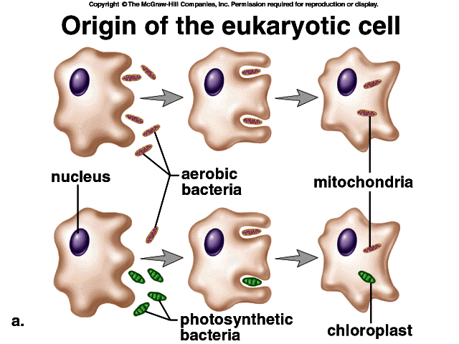
An extension of the endosymbiotic theory refers to plants. In this case, pigmented bacteria, such as the cyanobacteria, were engulfed by larger cells. The cyanobacteria remained in the cells and became the chloroplasts of these cells. Photosynthesis occurs in the chloroplasts of modern plant cells.
Origin of Organic Molecules
Scientists hypothesize that the universe came into existence about 15 billion years ago with a colossal explosion often referred to as the big bang. The gases and dust from that explosion produced the earliest generation of stars, and over a period of billions of years, the stars exploded, and their debris formed other stars and planets. The solar system was presumably formed in this way 4 to 5 billion years ago. During the next billion years, the molten earth cooled, forming a hardened, outer crust. About 3.5 billion years ago, living things came into being.
About 3.8 billion years ago, earth's atmosphere consisted of such elements as nitrogen, hydrogen, sodium, sulfur, and carbon. Some of these elements combined to form hydrogen sulfide, methane, water, and ammonia. Water vapor in this mist probably caused millions of years of torrential rains, during which the oceans formed. Gas and water from the earth's core came to the surface through volcanoes. Ultraviolet radiation bathed the earth, and the elements and compounds interacted with one another to form complex molecules.
In the early decades of the 20th century, Aleksandr Oparin and John Haldane independently suggested that if the primitive atmosphere was reducing (as opposed to oxygen-rich), and if there was an appropriate supply of energy, such as lightning or ultraviolet light, then a wide range of organic compounds might be synthesized.
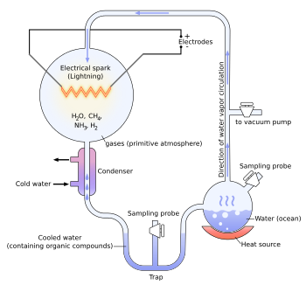
In 1953, Stanley Miller and Howard Urey performed a classic experiment to try to prove Oparin and Haldane Theory in which they circulated methane, ammonia, water vapor, and hydrogen gas in a closed environment and passed electric sparks through it. After several days, they discovered that complex compounds of carbon had formed in the mixture. Their experiments indicated that in the primitive earth atmosphere, complex organic molecules could form, including amino acids, carbohydrates, and nucleic acids. The theory they expressed is the primordial soup theory.
Recent theories about the origin of organic molecules suggest that these molecules may have formed in hydrothermal vents deep in the oceans, where hot gases and elements emerge from cracks in the earth's crust. Living organisms have been found near these vents, lending credence to the theory.
- Which scientists made the greatest contribution to evolution? Why do you feel this way?
- Analyze how the first organic compounds came to be.
- Do you feel evidence is sufficient to accept the explosion theory described above? Elaborate.

